Chapter 3, Solution 3

Applying KCL to the upper node,

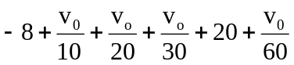= 0 or v₀ = –60 V

i₁ = 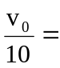 –6 A , i₂ = 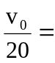 –3 A,
i₃ = 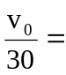 –2 A, i₄ = 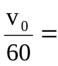 1 A.

